
P.O. Box 935
Madison, IN 47250

Membership New/Renewal
To renew your membership, please provide the following information and mail it with your dues to:
Big Oaks Conservation Society (BOCS)
P.O. Box 935
Madison, IN 47250

Please select the class of annual membership and dues you would like. Memberships commence on October 1 and run through September 30 of the fiscal year.

Golden Eagle/Corporate - $500
Supporting - $100
Family - $25
Individual - $15
Youth/Student - $5

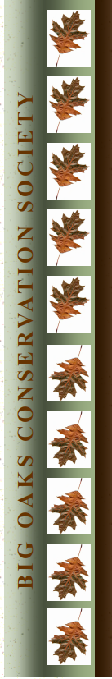
Name(s): ____________________________________________________________________________________________________________________
Address: ____________________________________________________________________________________________________________________
City, State, Zip: _____________________________________________________________________________________________________________
Telephone: ________________________________________ Email: ______________________________________________________________
My conservation interests are:

Thank you very much for your continued support of our mission. We and the refuge community truly do appreciate it.

